
Sreenidhi Institute of Science and Technology
Regulations:
A15
(An Autonomous Institution)
Code No: 5B306 Date:24-Nov-16
B. TECH. II-Year I-Semester Examinations, Nov/Dec 2016 (Regular)
MECHANICS OF SOLIDS (ME)

Time: 3 Hours Max. Marks: 75

Note: A) No additional answer sheets will be provided.
B) Assume any missing data

Part - A
Max.Marks:25
Answer all QUESTIONS
- Explain the terms: Longitudinal strain, Lateral strain and Poisson’s ratio. (3M)
- Define Principal planes and Principal stresses. (3M)
- Name the different types of beams. Differentiate between a cantilever beam and a simply supported beam. (3M)
- What is meant by section modulus? Find an expression for section modulus of a rectangular section. (3M)
- Define slenderness ratio. State the limitations of Euler’s formula. (3M)
- Distinguish between thin and thick cylinders. (2M)
- Discuss about factor of safety. (2M)
- Show that the bending stress in any fibre is proportional to the distance of that fibre from neutral layer in a beam. (2M)
- Write the slope and deflection equation of a simply supported beam, carrying a point load at its centre. (2M)
- Explain about longitudinal stress in thin shells. (2M)
Part – B
Max.Marks:50
ANSWER ANY FIVE QUESTIONS. EACH QUESTION CARRIES 10 MARKS.
Note:- All sub-sections of a question must be answered at one place only
- A steel rod of 20mm diameter passes centrally through a copper tube of 50mm external diameter and 40mm internal diameter. The tube is closed at each end by rigid plates of negligible thickness. The nuts are tightened lightly on the projecting parts of the rod. If the temperature of the assembly is raised by 50 ⁰C, calculate the stresses developed in copper and steel. Take E for steel and copper as 200 GN/m² and 100 GN/m² and α for steel and copper as 12x 10⁻⁶ per ºC and 18x10⁻⁶ per ºC.

- The principal tensile stresses at a point on two perpendicular planes are 60 MPa and 30 MPa. Find normal, tangential and resultant stress and its obliquity on a plane at20⁰ with the major principal plane as shown in fig below. Also find the intensity of stress which acting alone can produce the same maximum strain. Assume Poisson’s ratio as 0.3.
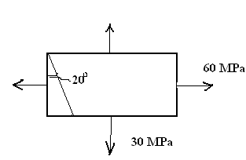

- Draw the shear force and bending moment diagram for the beam shown in fig below. Find the point of contraflexture
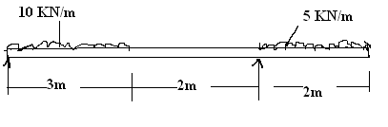
- The cross section as shown in fig below is used as a simply supported beam on a span of 4m. If allowable stress in bending in compression and tension is 100MPa and 165MPa respectively, find the safe UDL the beam can carry.
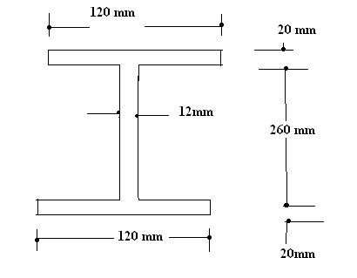
- A circular steel strut of 25mm diameter, 1m long is subjected to an axial thrust of 12 KN. In addition a lateral load W acts at the centre of the strut. If the strut is to fail at Maximum stress of 320N/mm², determine the magnitude of W. Take E= 210KN/mm².

- A thin spherical shell of 1.5m diameter is 10mm thick. It is filled with liquid at internal pressure of 3MPa. Find the hoop stress, change in thickness and change in volume. Assume E = 200Gpa and µ =0.3.

- a) Derive the expression of stress due to impact load.
b) Derive an expression for the shear stress produced in a circular shaft which is subjected to torsion. What are the assumptions made in the derivation?

8. A beam of length 5m and of uniform rectangular section is supported at its ends and carries uniformly distributed load over the entire length. Calculate the depth of the section if the maximum permissible bending stress is 8 N/mm² and central deflection is not to exceed 10mm. Take ratio between depth to width as 2.

-- 00 -- 00 --

